Instalación de Docker

Update the apt package index and install packages to allow apt to use a repository over HTTPS
$ sudo apt-get update

$ sudo apt-get install \
apt-transport-https \
ca-certificates \
curl \
gnupg-agent \
software-properties-common
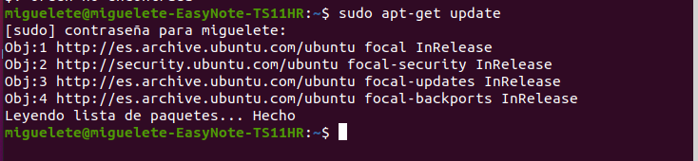
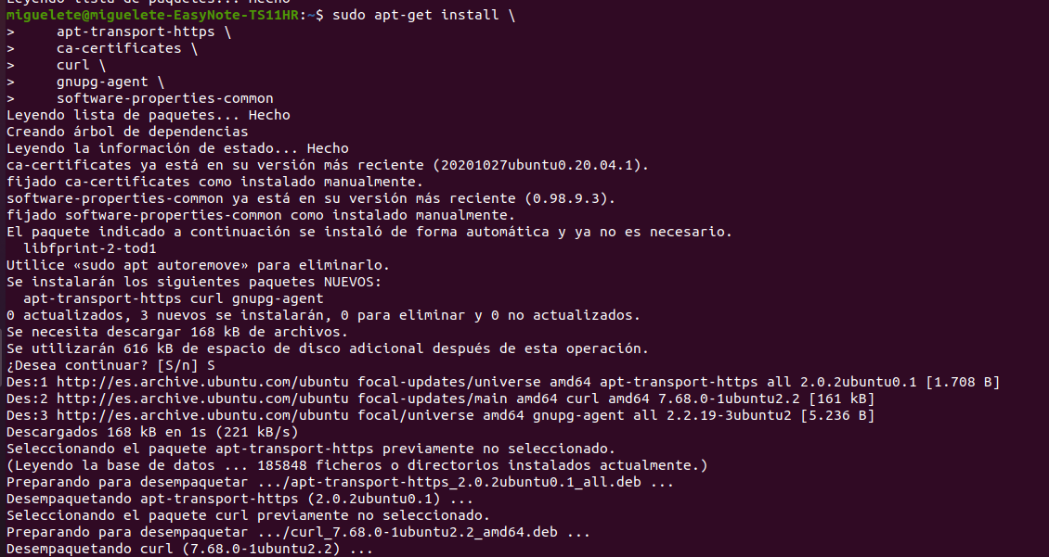
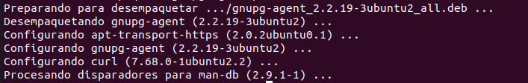

Add Docker’s official GPG key
$ curl -fsSL https://download.docker.com/linux/ubuntu/gpg | sudo apt-key add -
$ sudo apt-key fingerprint 0EBFCD88

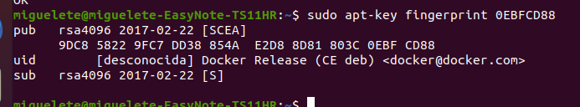

$ sudo add-apt-repository \
"deb [arch=amd64] https://download.docker.com/linux/ubuntu \
$(lsb_release -cs) \
stable"
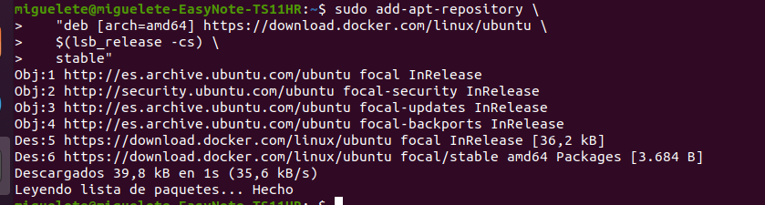

Install Docker Engine
Update the apt package index, and install the latest version of Docker Engine and containerd, or go to the next step to install a specific version:
$ sudo apt-get update
$ sudo apt-get install docker-ce docker-ce-cli containerd.io
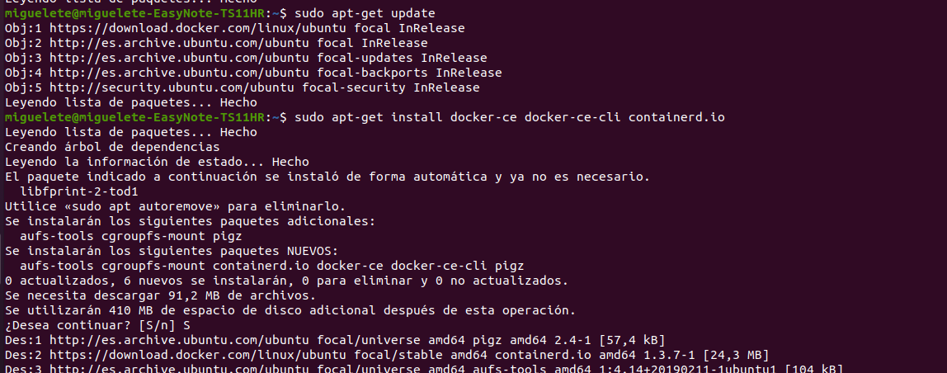

Comprobamos la version de Docker
$ sudo docker version
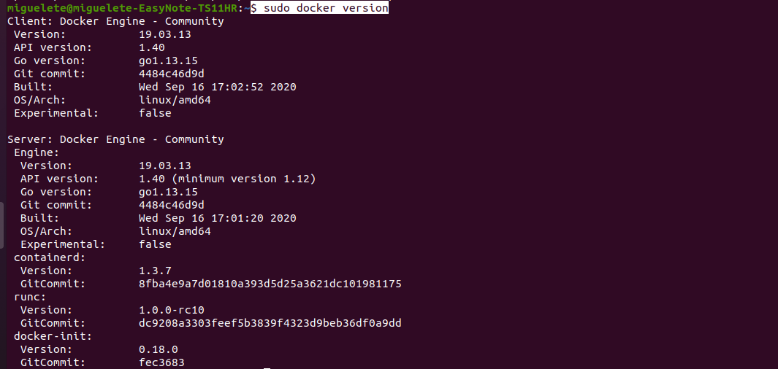
$ sudo docker run hello-world

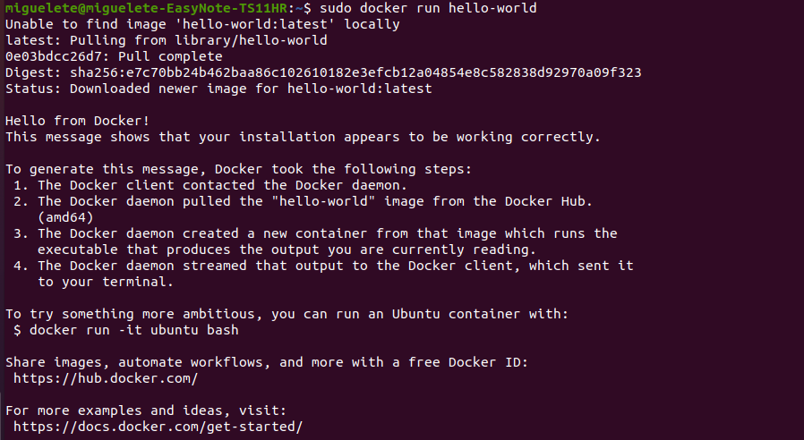
Para evitar poner sudo cada vez que realizamos alguna tarea:

$ sudo usermod -aG docker your-user

Habrá que salir y volver a entrar para que haga efecto

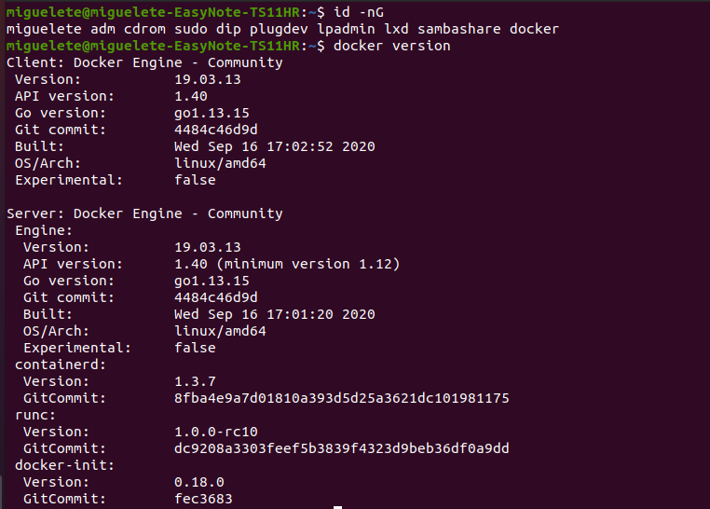

Instalación de Docker compose
Ejecutamos el siguiente comando:
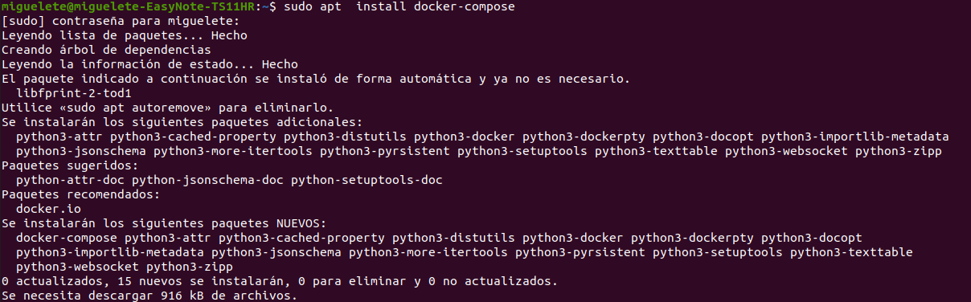
$ sudo apt install docker-compose

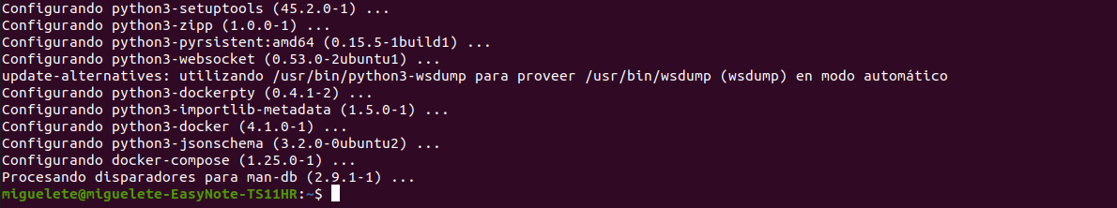
Ya tenemos docker-compose instalado:

